PRE REQUISTIES IBM CLOUD SERVICES

|  |  |
| --- | --- |
| **TEAM ID** | **PNT2022TMID28861** |
| **PROJECT NAME** | **IOT BASED SMART CROP PROTECTION SYSTEM FOR**  **AGRICULTURE** |

STEP 1:

Create your IBM cloud account using web mail and password using <http://ibm.com/academic/home>URL. Then sign in your username and password.

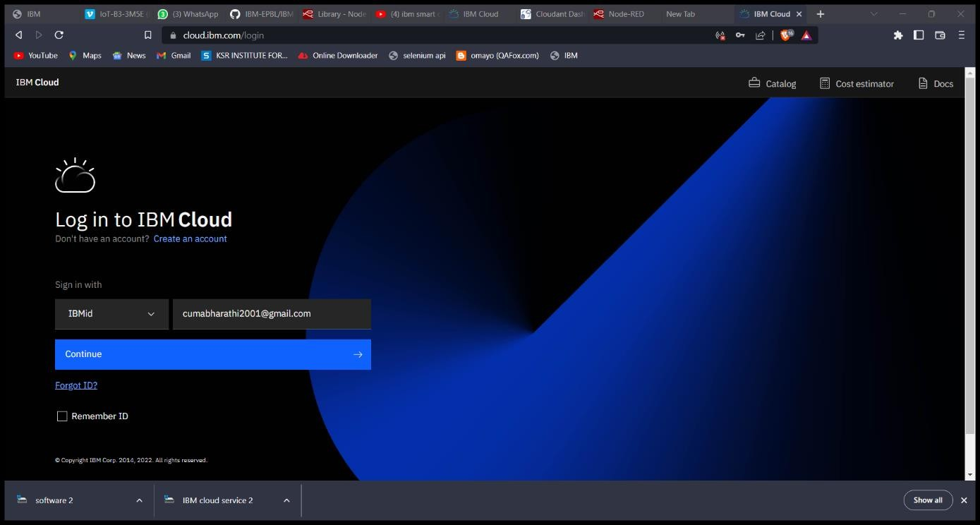

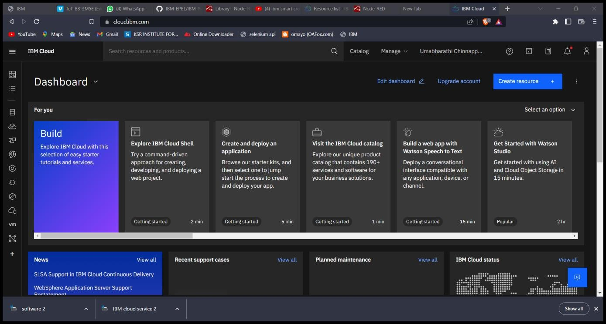

STEP 2:

Next search IBM IoT Watson platform. Then create IBM IoT Watson and launch it.

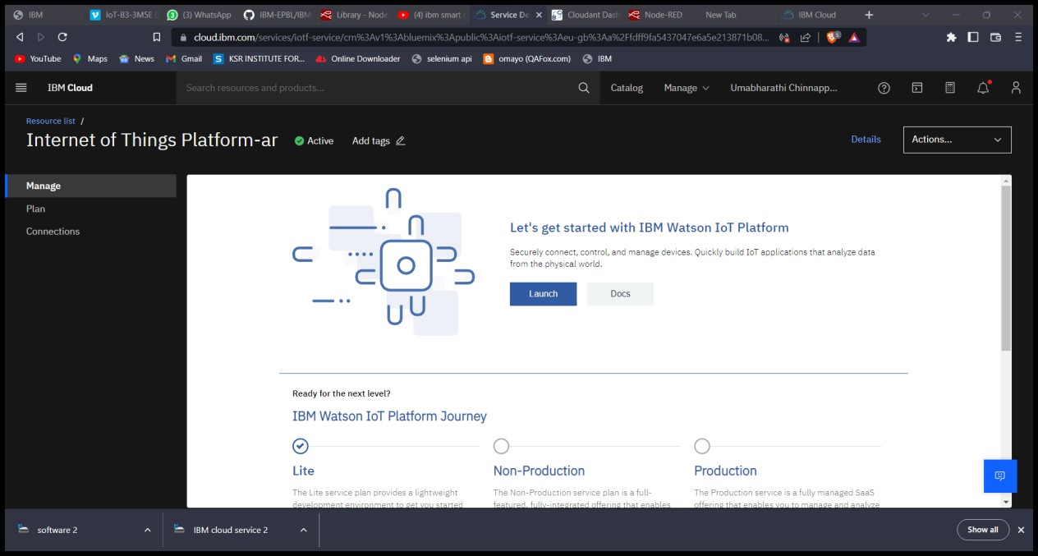

STEP 3:

Next search Node-Red service in search bar. Then create Node-Red account and launch Node-Red service. It shows the dashboard of Node-Red service.

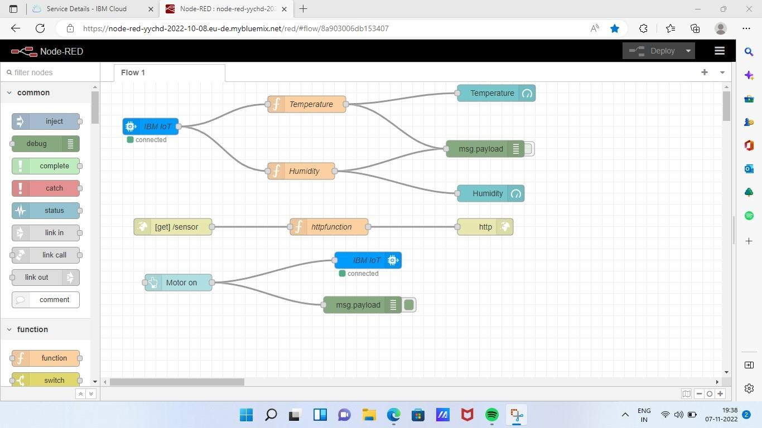

Step 4: Open [node-red-yychd-2022--cloudant-1667643063389-1946 open](https://cloud.ibm.com/services/cloudantnosqldb/4a3f98e7-9f85-423d-b52e-d90aff5c6232?env_id=ibm%3Ayp%3Aeu-de) [this link.](https://cloud.ibm.com/services/cloudantnosqldb/4a3f98e7-9f85-423d-b52e-d90aff5c6232?env_id=ibm%3Ayp%3Aeu-de)

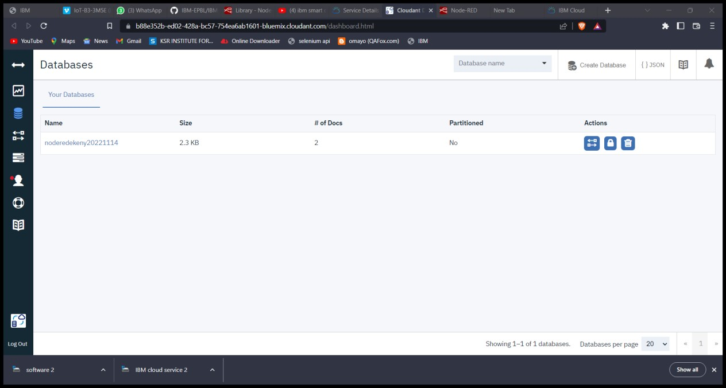

STEP 5:

Search object storage in search bar, then click object storage. Click create button in bottom right corner.

